ETF screener / evaluator

1. Morningstar

<https://www.morningstar.com/etfs/xasx/ivv/quote.html>

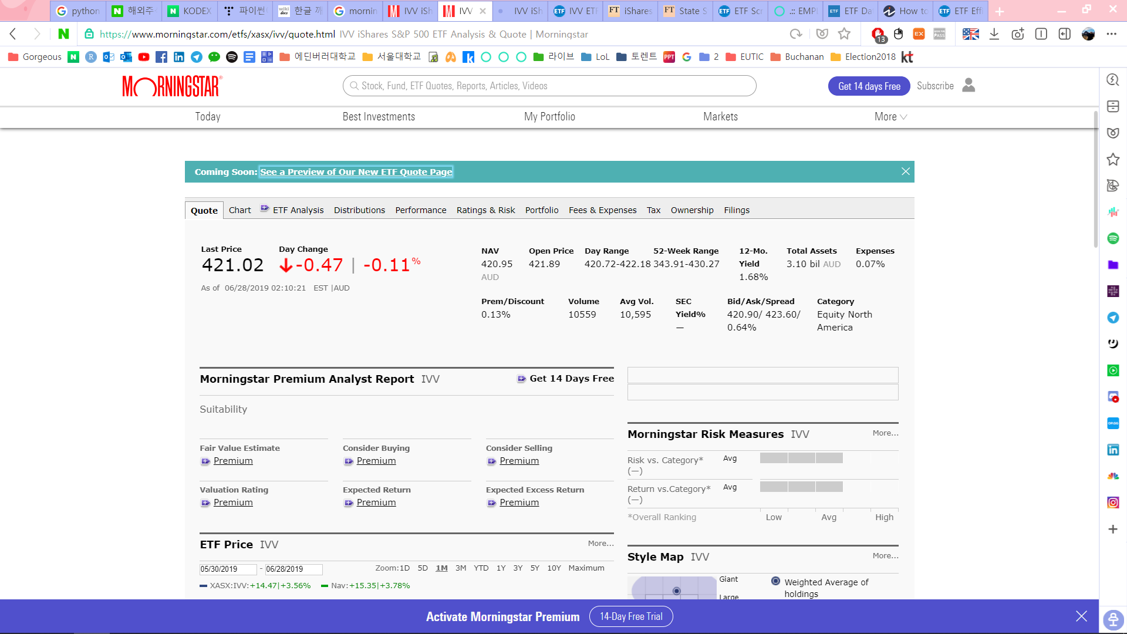

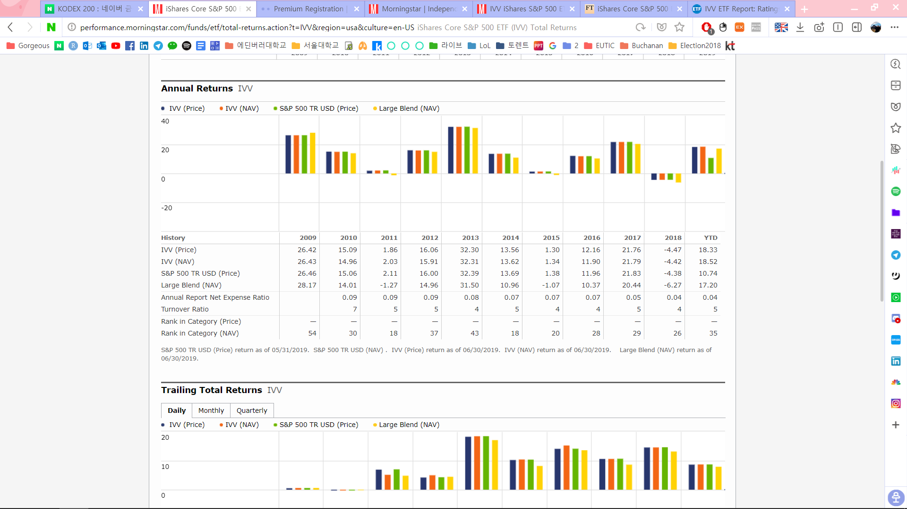

1. ETF.com

<https://www.etf.com/IVV#fit>

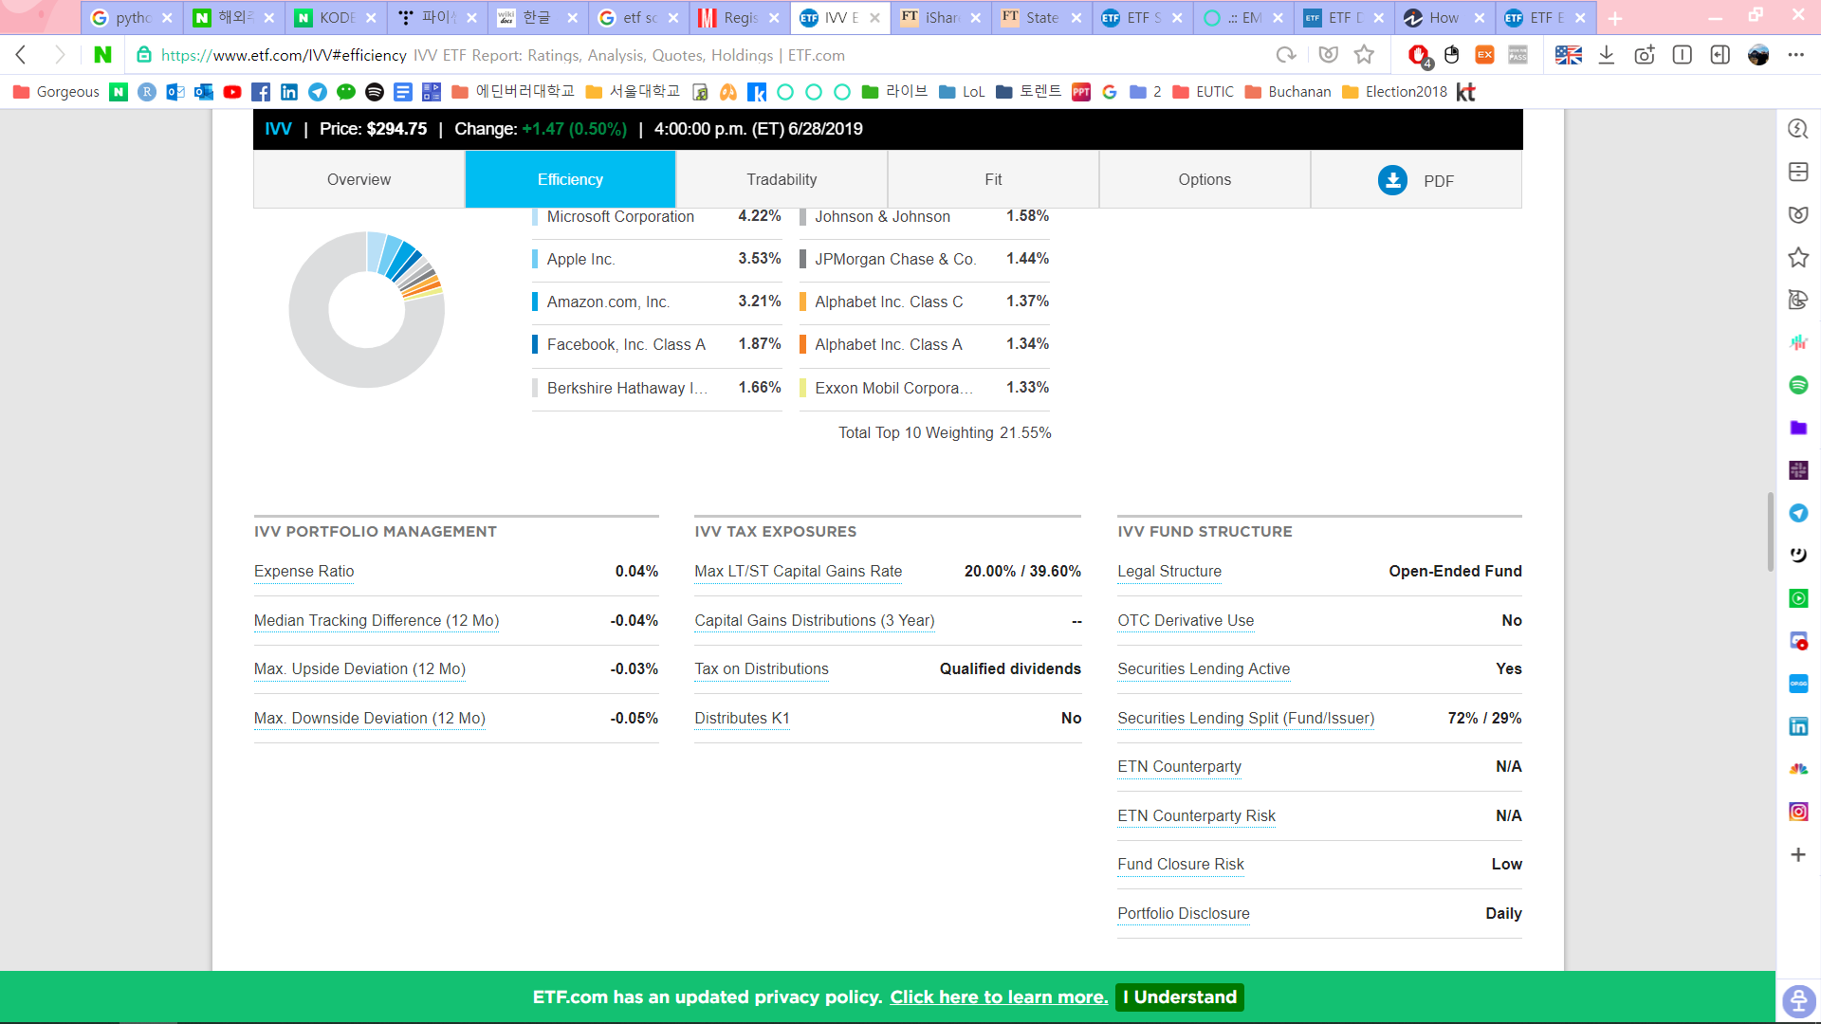

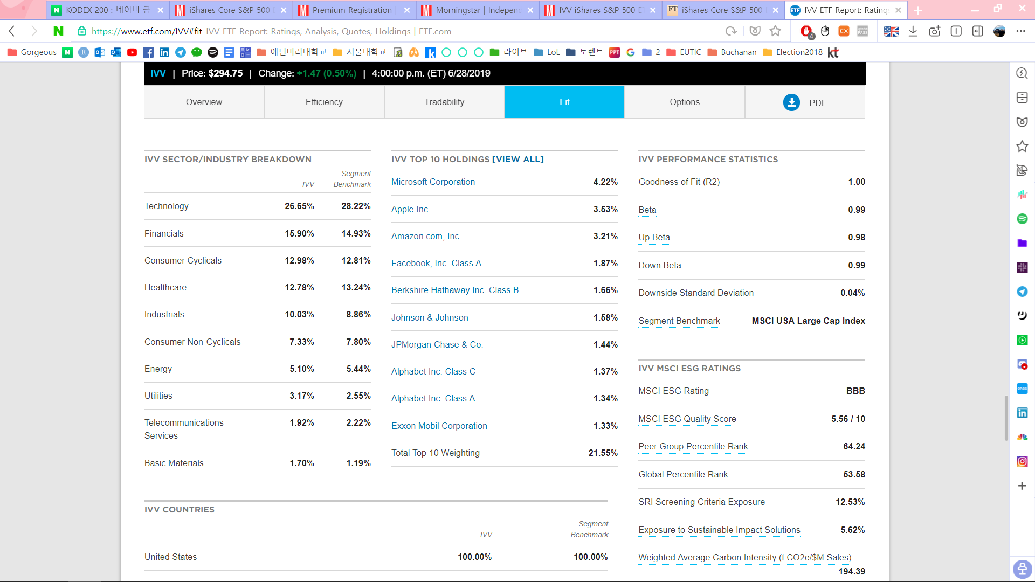

1. Financial Times

<https://markets.ft.com/data/etfs/tearsheet/summary?s=IVV:PCQ:USD>

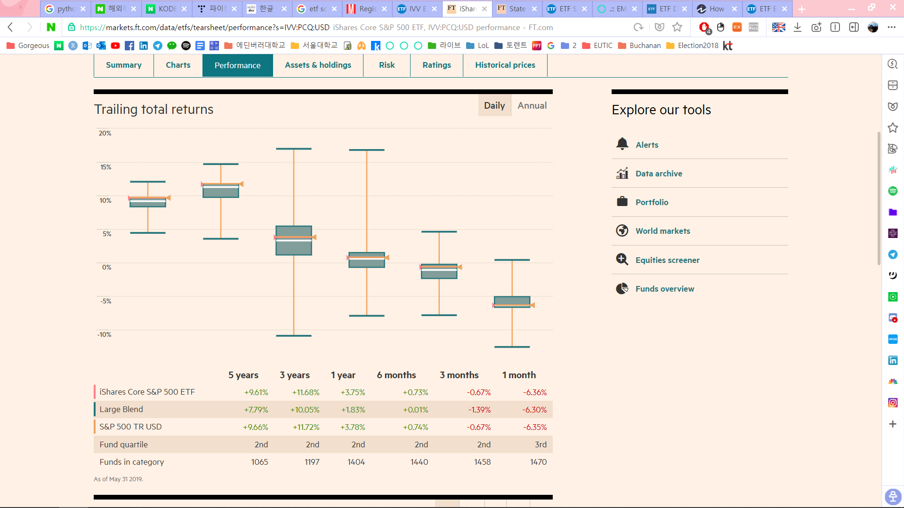

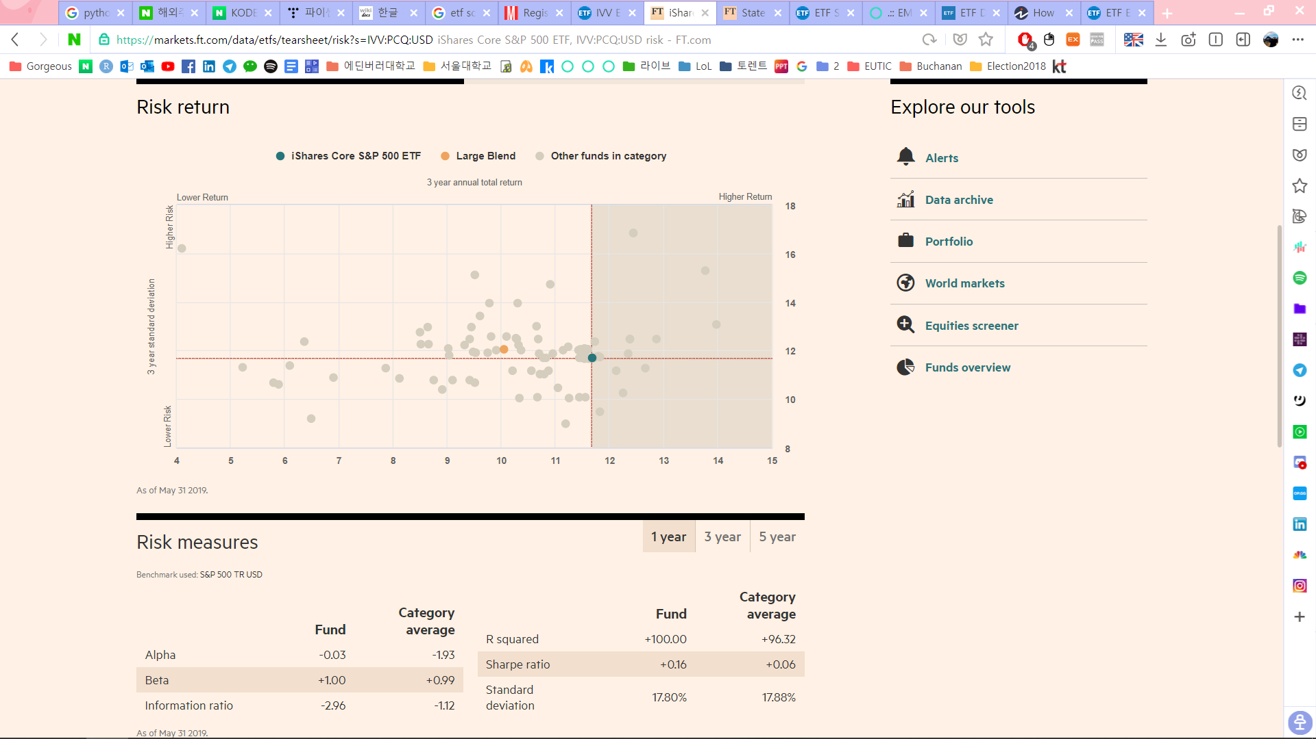

1. Yahoo Finance

<https://finance.yahoo.com/quote/IVV?p=IVV&.tsrc=fin-srch>

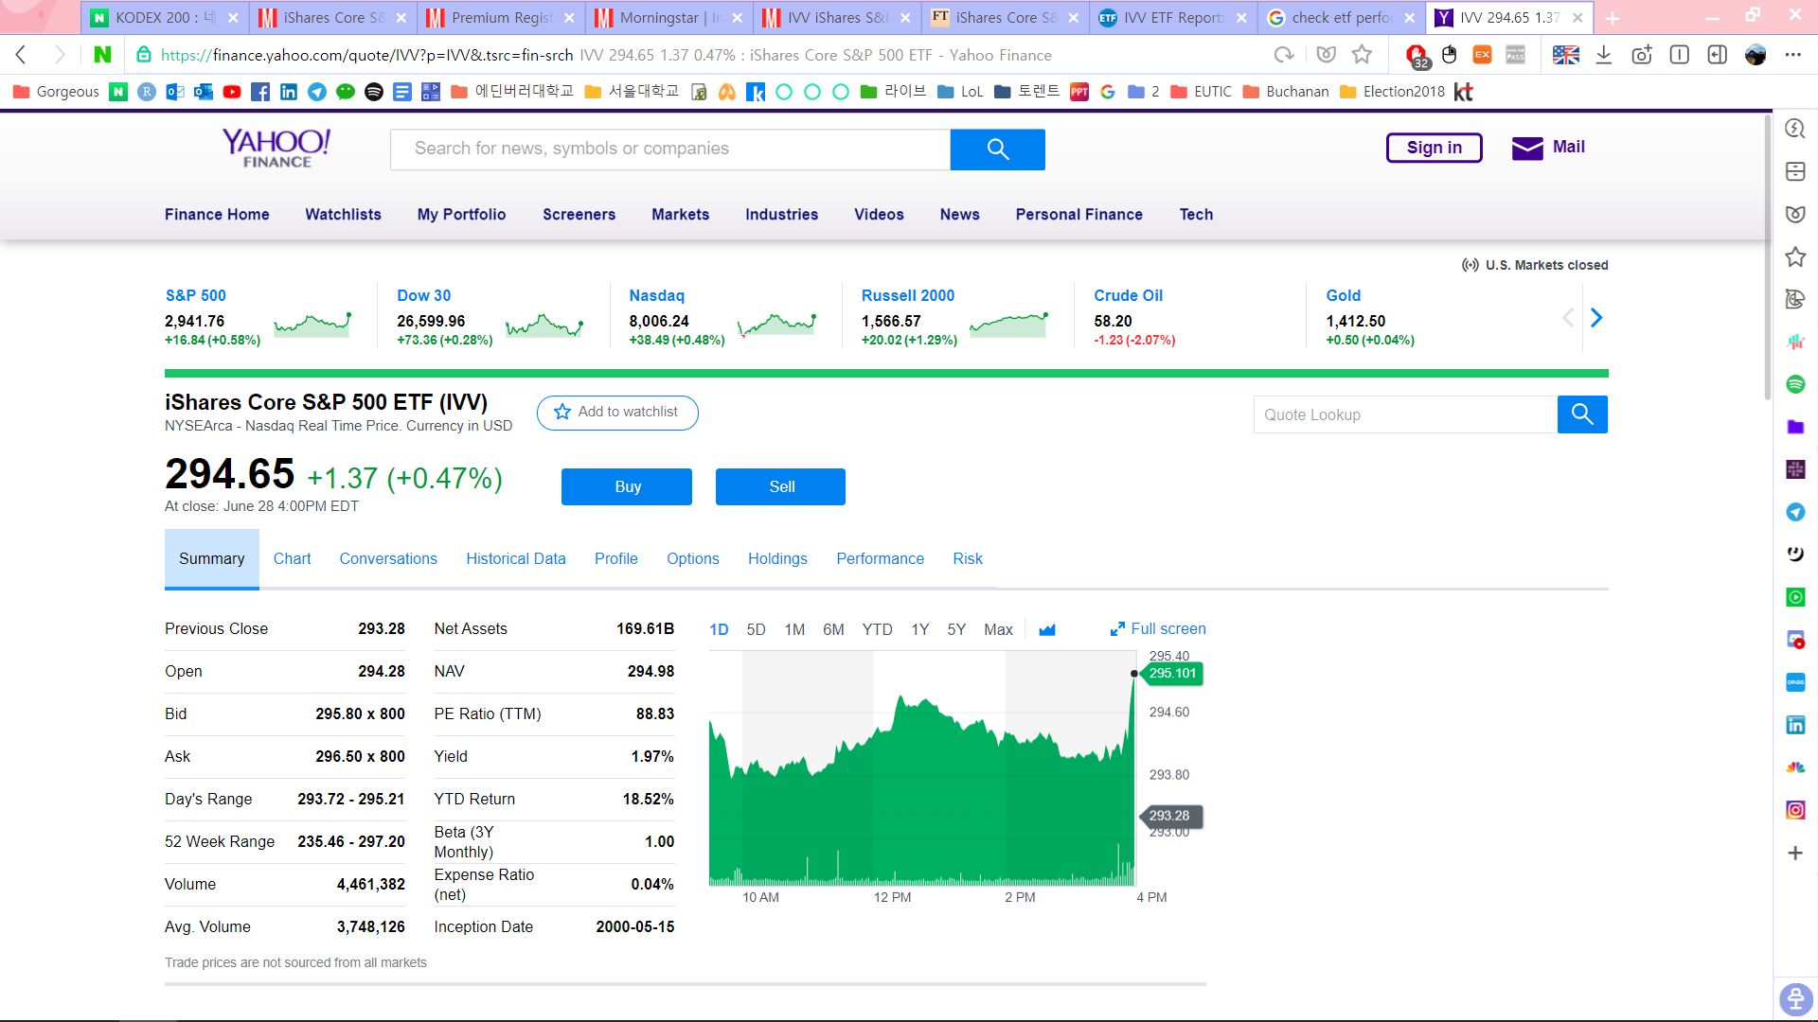

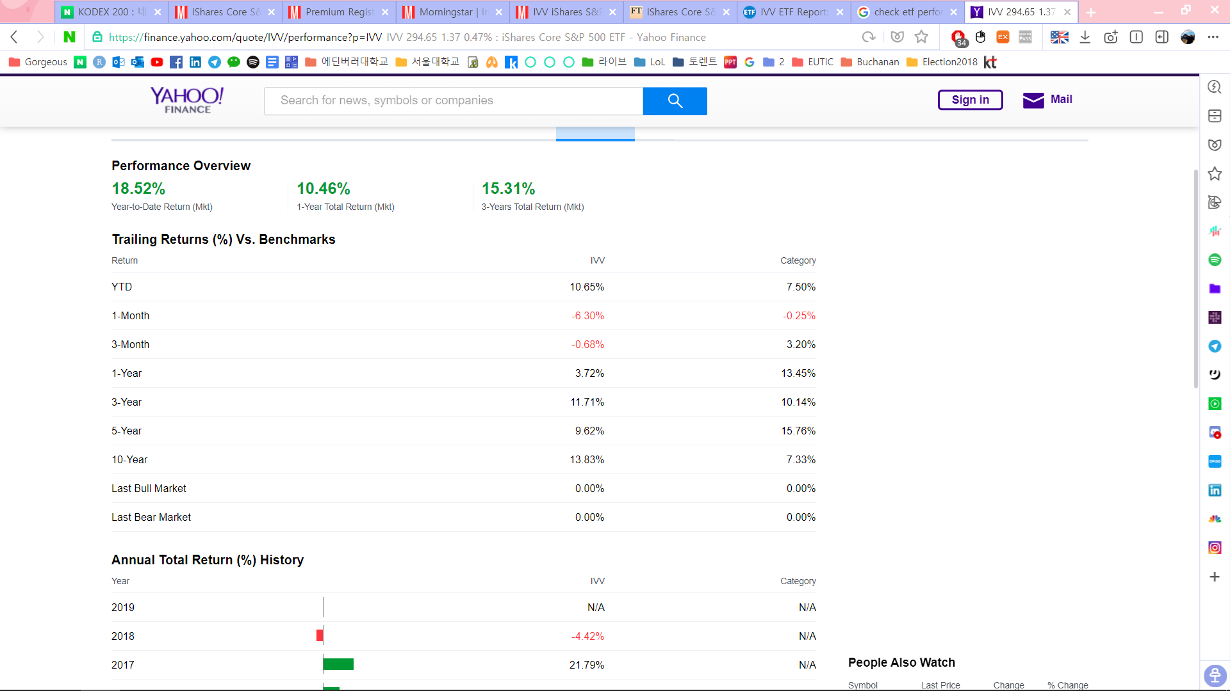

1. Marketwatch

<https://www.marketwatch.com/investing/fund/ivv/profile>

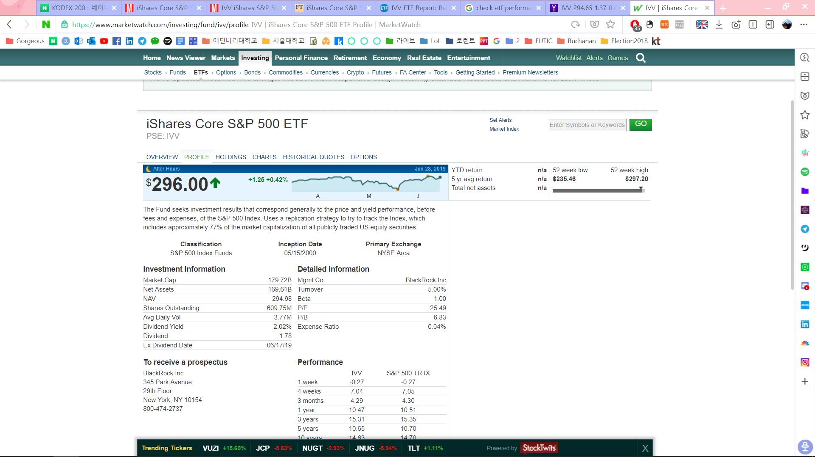

|  |  |  |  |  |  |  |
| --- | --- | --- | --- | --- | --- | --- |
|  | Naver | MorningStar | ETF.com | Financial Times | Yahoo Finance | MarketWatch |
| Price / Chart | O | O | O | O | O | O |
| Profile | O | O | O | O | O | O |
| NAV & Trend | O | O (no trend) |  |  | O (no trend) | O (no trend) |
| Holdings | O | O | O | O | O | O |
| Asset Breakdown |  | O | O | O | O | O |
| Trading Vol. | O | O | O |  | O | O |
| Trailing Return |  | O |  | O | O |  |
| Growth of 10000 |  | O |  |  |  |  |
| Annual Return | O | O |  |  | O | O |
| Benchmark |  | O | O |  | O |  |
| Risk / Rating |  | O |  | O |  |  |
| Performance Stats |  | O | O |  | O |  |
| MSCI ESG Ratings |  |  | O |  |  |  |
| PE Ratio |  | O | O |  | O | O |
| Dividend Yield |  | O | O |  |  | O |
| WAMC | O | O | O |  | O | O |
| Beta | O |  | O |  | O | O |
| Net Expense Ratio | TER | O | O | O | O | O |
| Cash Flow Growth |  | O |  |  |  |  |
| Ownership | O | O |  |  |  |  |
| Tax |  | O |  |  |  |  |